Grantium guidance for applicants
How to acknowledge a decision

Version 2 – February 2018

When a decision has been reached about your application, you will receive an email notification. This will be delivered to the email address you entered when you created your account, and will look like this:

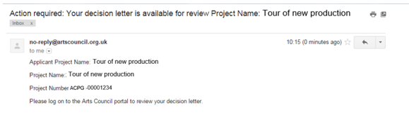

Once you have received your notification, you need to log into the system using your account details.

Once you have logged in, click Submissions in the navigation bar on the left of the screen.

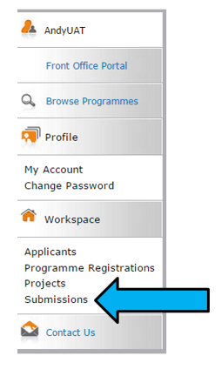

Select the relevant applicant from the dropdown at the top of the Submissions screen and use the filters to select the relevant project.

Listed here, you will see the Eligibility questionnaire and Application that you submitted. You will also see a new item which will either be titled Offer letter acknowledgement, Funding agreement acknowledgement or Decision letter, depending on the decision made on your application.

Click the open icon to view the letter.

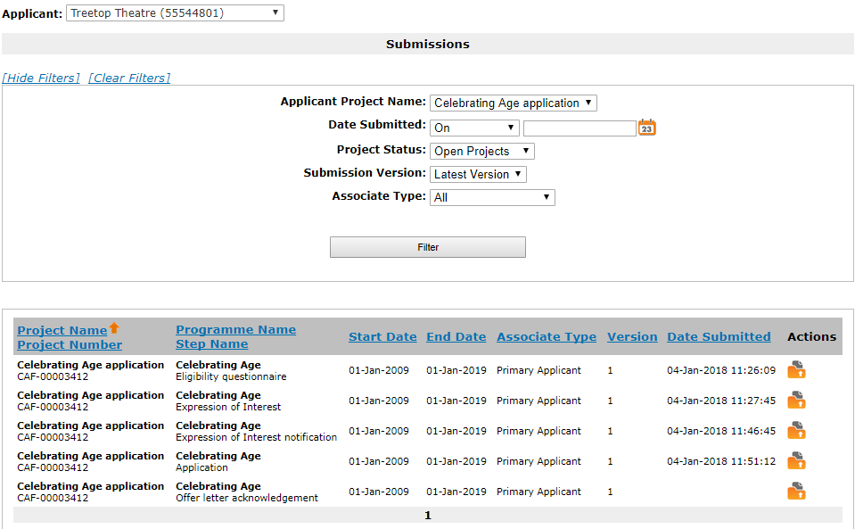

If your application was successful

If your application was successful, you will see an Offer letter acknowledgement.

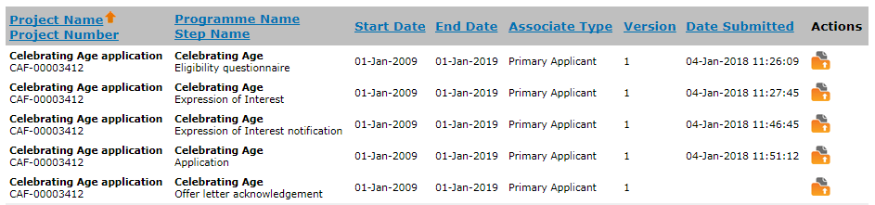

Click the open icon to view the letter.

The first screen is the Project information screen. This gives some basic details about the project. There is nothing on this screen that requires action.

Click Next to proceed.

For Arts Council Project Grants for more than £15,000, and for some Strategic Funds, your application will have been appraised or assessed and the next screen will be the Appraisal screen. If you applied for less than £15,000 for ACPG, your application will have gone through the risk check process and the next screen you will see is the Offer Letter screen. If you applied for National Portfolio funding, your assessment will not form part of your funding agreement, but can be viewed by referring to your conditional decision notification. Please turn to page 5 for guidance on this screen.

On the Appraisal screen you will see how your application was scored and the comments the appraiser made.

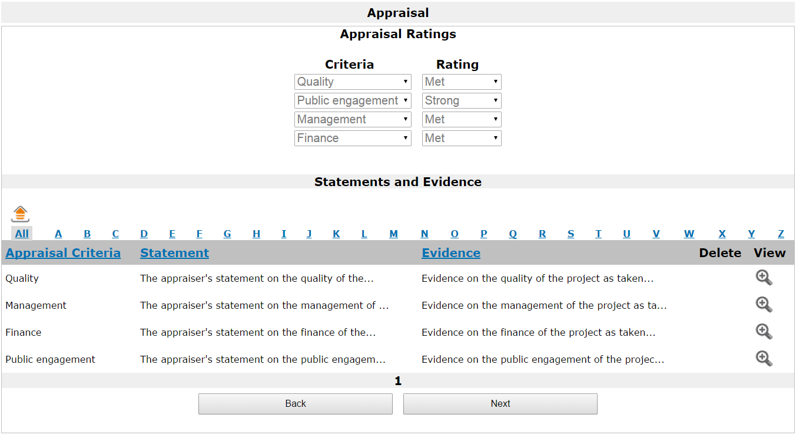

At the top of this screen, the Appraisal Ratings section shows the rating against each of our criteria: Quality, Public engagement, Management, and Finance (for Arts Council Project Grants – other funding programmes may have different criteria, which will be explained in the programme specific guidance). The ratings we use are: Outstanding, Strong, Met, Potential, or Not met.

In the Statements and Evidence section, you can see the appraiser’s statements against each of the appraisal criteria, and the evidence this statement is based on. To read these in full, click the View icon on the relevant line.

This opens the Statements screen where you can read the statements in full.

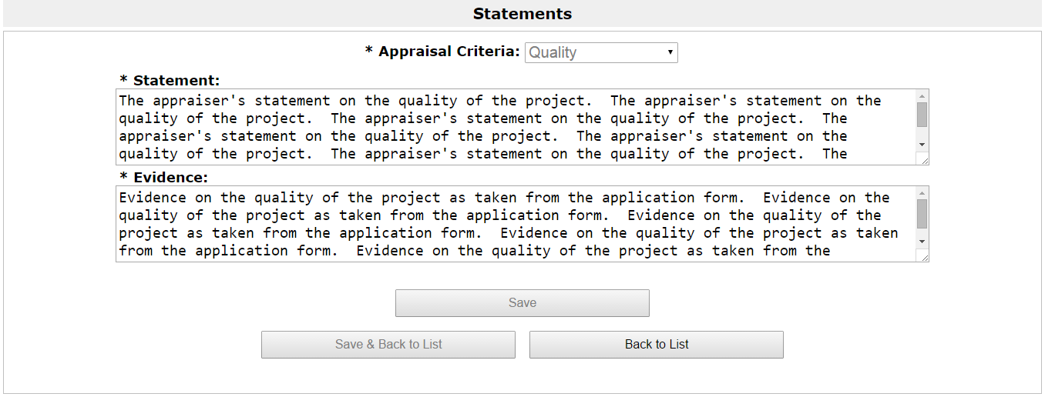

To return to the Appraisal screen, click Back to List.

For more information about the appraisal process, please see our information sheet ‘Appraisal process for Grants for the Arts’.

When you are ready to move on from the Appraisal screen, click Next.

The next screen is the Offer letter itself. The offer letter contains details of your project, including payment dates and conditions.

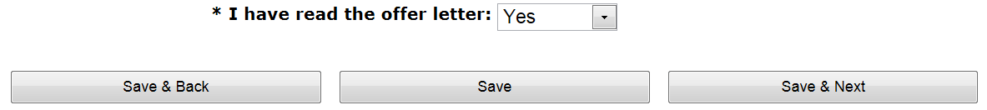

Once you have read the letter, confirm that you have done so by selecting Yes from the dropdown at the bottom of the screen.

Click Save & Next to proceed.

The next screen is the Attachments screen. From this screen you can download our Bank details form and our standard Terms and conditions for grants.

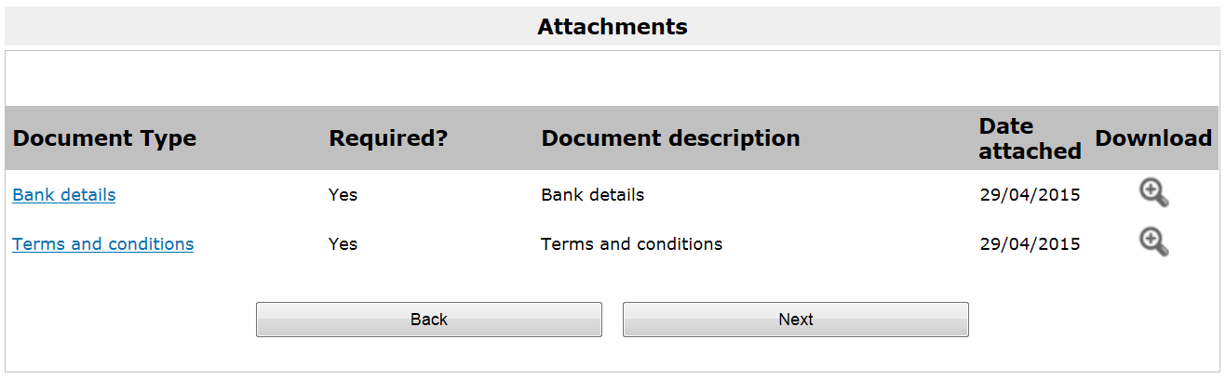

Please read the Terms and conditions.

The Bank details form should be printed and completed in hardcopy, and returned to:
Grant Management
Arts Council England
The Hive
49 Lever Street
Manchester
M1 1FN
Do not send your bank details electronically, or attach them to your Initial payment request.

Click Next to continue.

Next is the Acknowledgement screen, on which you confirm acceptance of the offered grant and grant conditions. This screen will look different depending on whether you are an individual or an organisation.

As an individual, the Acknowledgement screen will look like this:

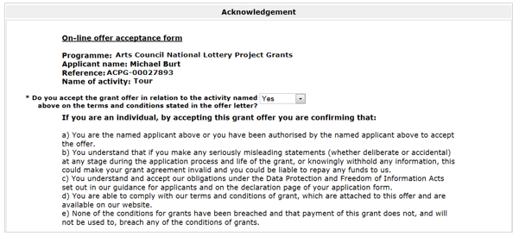

Select Yes from the dropdown and click Save & Next to proceed.

As an organisation, the Acknowledgement screen will look like this:

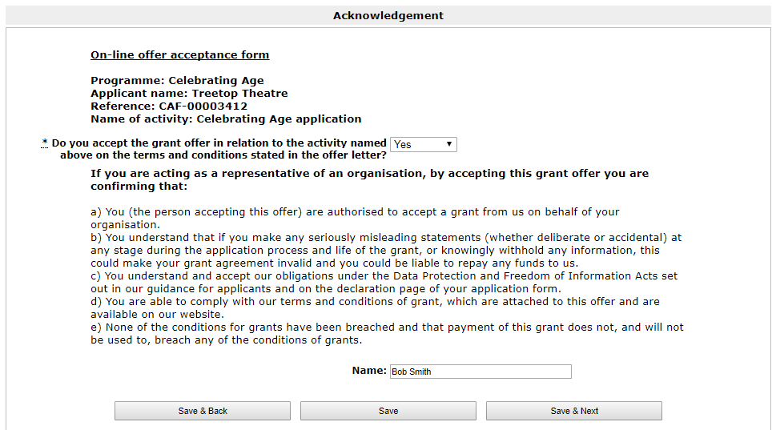

Select Yes from the dropdown and click Save & Next to proceed.

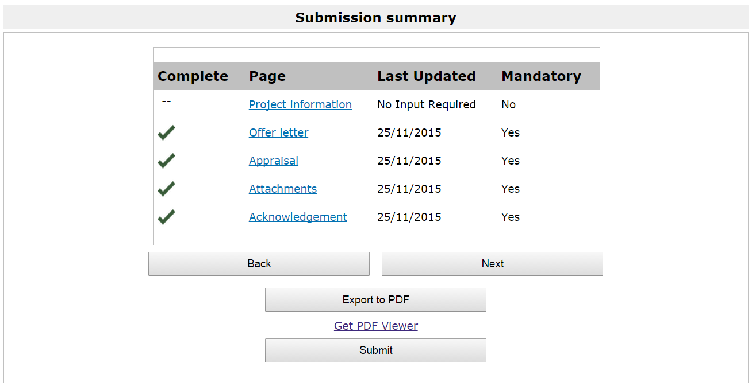

On the Submission summary screen, click Submit to complete the process.

Claiming your first grant payment from us involves an additional process. Please refer to our information sheet ‘How to claim a payment’ for guidance on doing this.
If your application was not successful

If your application was not successful, you will see a Decision letter.

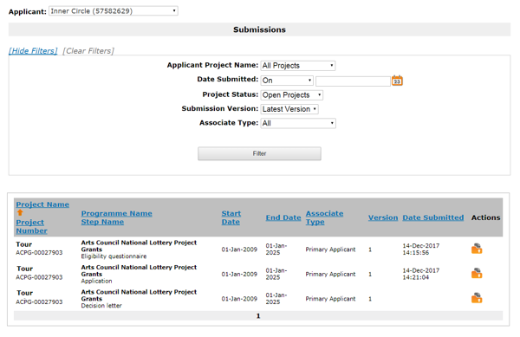

Click the open icon to view the letter.

The first screen is the Project information screen. This gives some basic details of the project. There is nothing on this screen that requires action.

Click Next to proceed.

For Arts Council Project Grants for more than £15,000, and for some Strategic Funds, your application will have been appraised or assessed and the next screen will be the Appraisal screen. If you applied for less than £15,000 for ACPG, your application will have gone through the risk check process and the next screen you will see is the Decision Letter screen. Please turn to page 11 for guidance on this screen.

On the Appraisal screen you will see how your application was scored and any comments the appraiser made.

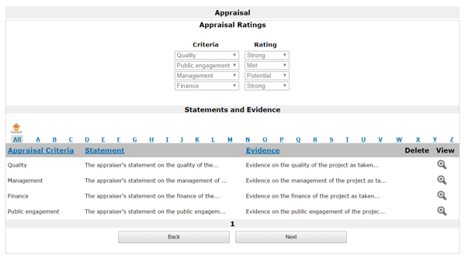

At the top of this screen, the Appraisal Ratings section shows the ratings against each of our criteria: Quality, Public engagement, Management, and Finance. The ratings we use are: Outstanding, Strong, Met, Potential, or Not met.

In the Statements and Evidence section, you can see the appraiser’s statement against each of the appraisal criteria and the evidence this statement is based on. To read these in full, click the View icon on the relevant line.

This opens the Statements screen where you can read the statements in full.

To return to the Appraisal screen, click Back to List.

For more information about the appraisal process, please see our information sheet ‘Appraisal process for Grants for the Arts’.

When you are ready to move on from the Appraisal screen, click Next.

The next screen is your Decision letter itself. An extract is shown below.

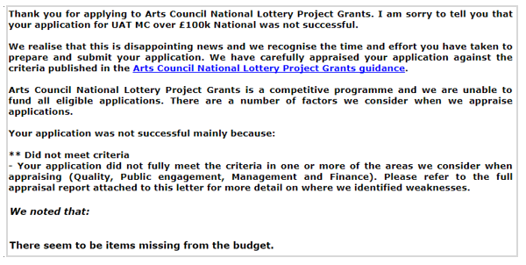

The letter will explain the reason we came to our decision.

Click Next to proceed.

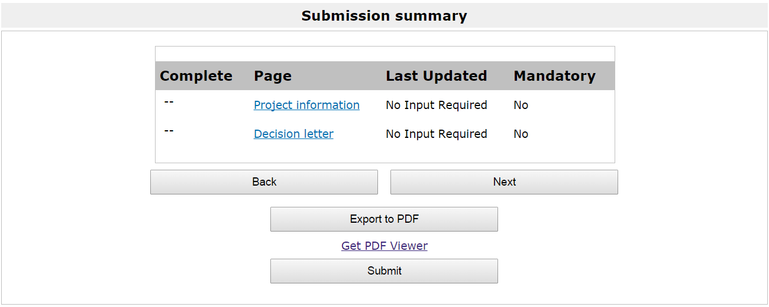

On the Submission summary screen, click Submit to complete the process.

Further information and support

If you have any questions about the information contained in this document or require some assistance, please contact our Customer Services team on:

Phone: 0845 300 6200, 0161 934 4317
Textphone: 0161 934 4428
Email: enquiries@artscouncil.org.uk
Website: www.artscouncil.org.uk

